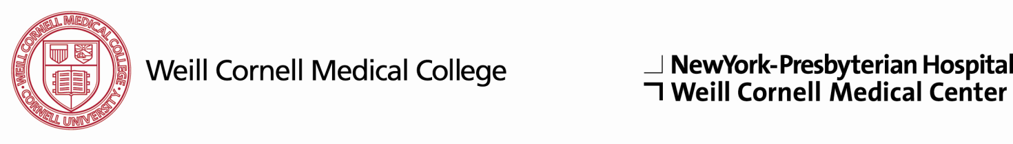

Department of Medicine

NewYork-Presbyterian Hospital

Weill Medical College of Cornell University

Medical Research Track

Training Program

Name:

Medical School:

Fellowship:

PLEASE ANSWER QUESTIONS 1-3 SEPARATELY AND ATTACH TO THIS FORM. USE AS MUCH SPACE AS YOU NEED.

- Describe the research you have conducted to date and its significance.

- Describe your career plans and goals, including any research or clinical interests you may have developed. If known, please indicate the area(s) of subspecialty medicine in which you are interested.

- List individuals with whom you would like to meet during your visit to NewYork-Weill Cornell in your order of interest.

- Please list the individuals from whom you have requested letters of recommendation for this track. One of these letters should be from your primary research mentor/supervisor or thesis advisor for applicants who have completed a PhD, and one other individual familiar with your research.

Name | Phone Number | E-Mail Address

PLEASE E-MAIL THIS COMPLETED FORM, ANSWERS TO QUESTIONS 1-3, AND COPIES OF YOUR RELEVANT PUBLICATIONS AS ONE PDF FILE TO:
nypcornell-imresidency@med.cornell.edu

